# Testing

It is the simply process of conduction where the codes of system is validated and debugged. It is simply categorized into two types of testing and they are:

-White-box Testing

-Black-box Testing

White-box Testing simply includes the types of testing where the codes of test process conduct are visible i.e. Testing process is detectable and transparent.

Black-box on the other hand includes those types of testing where the codes of test process conduct are not visible i.e. Testing process is un-detectable and opaque.

For White-Box Testing I have used Junit java testing in android studio because it is simple and easy to conduct. These are some of the testing processes that are into this category.

White-Box Testing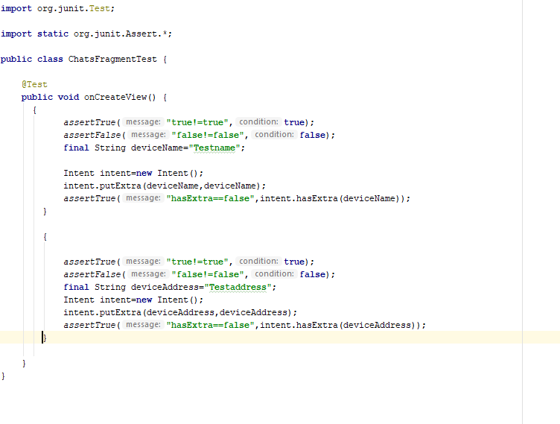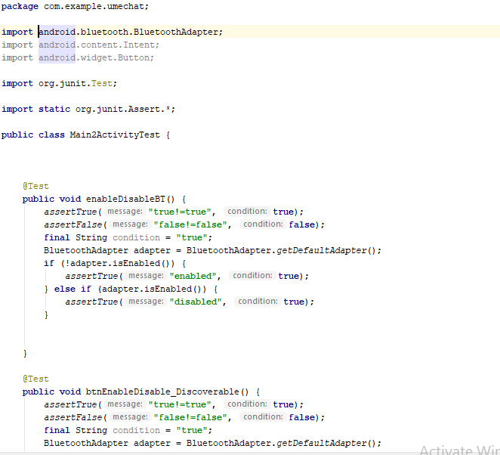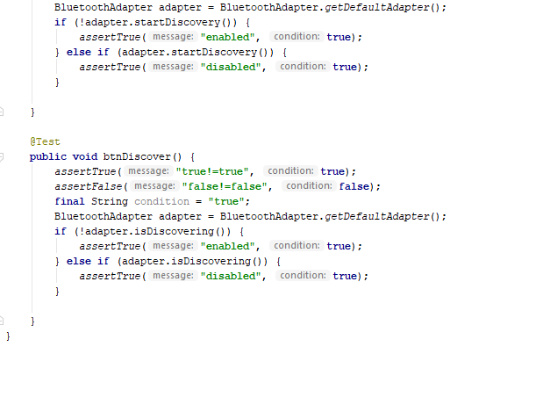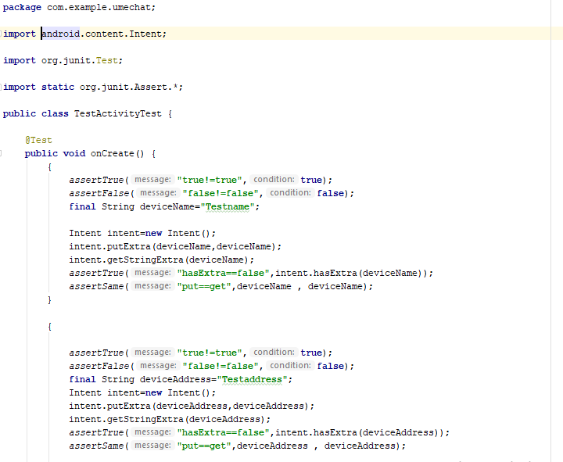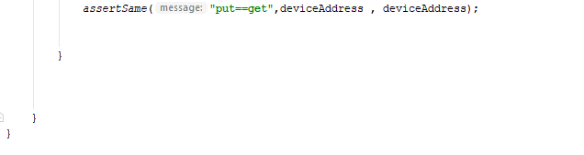

Test-Result Profiler

Here we run the test by simply right-clicking on the test and execute the test and profiler dialogue of test result is shown as shown in the below diagrams.

ChatsFragmentTest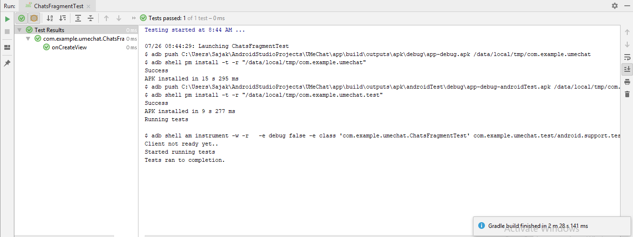Main2ActivityTest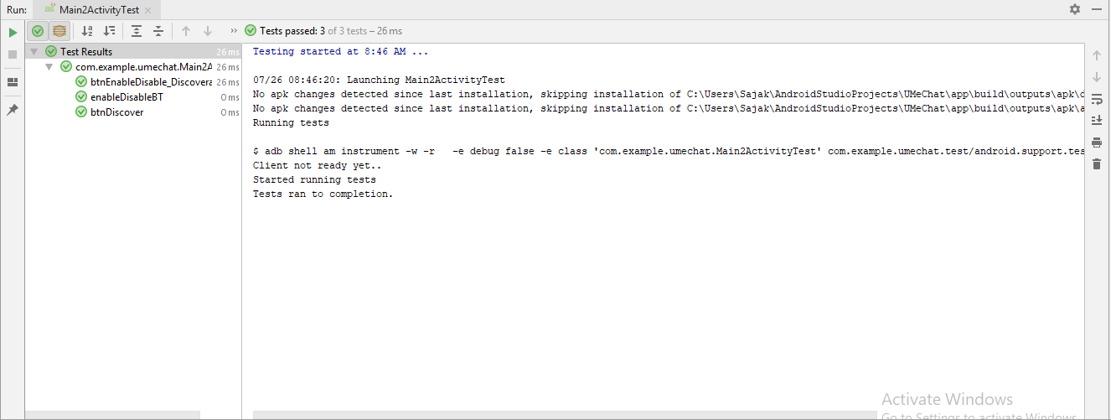TestActivityTest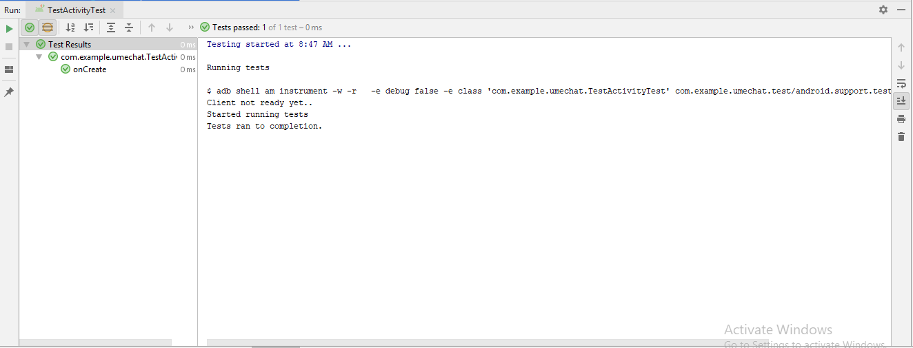

For Black-Box testing I have simply run the application in my device and screenshot the performance and these are some test process in this category.

Black-Box Testing:

Application Start-Phase

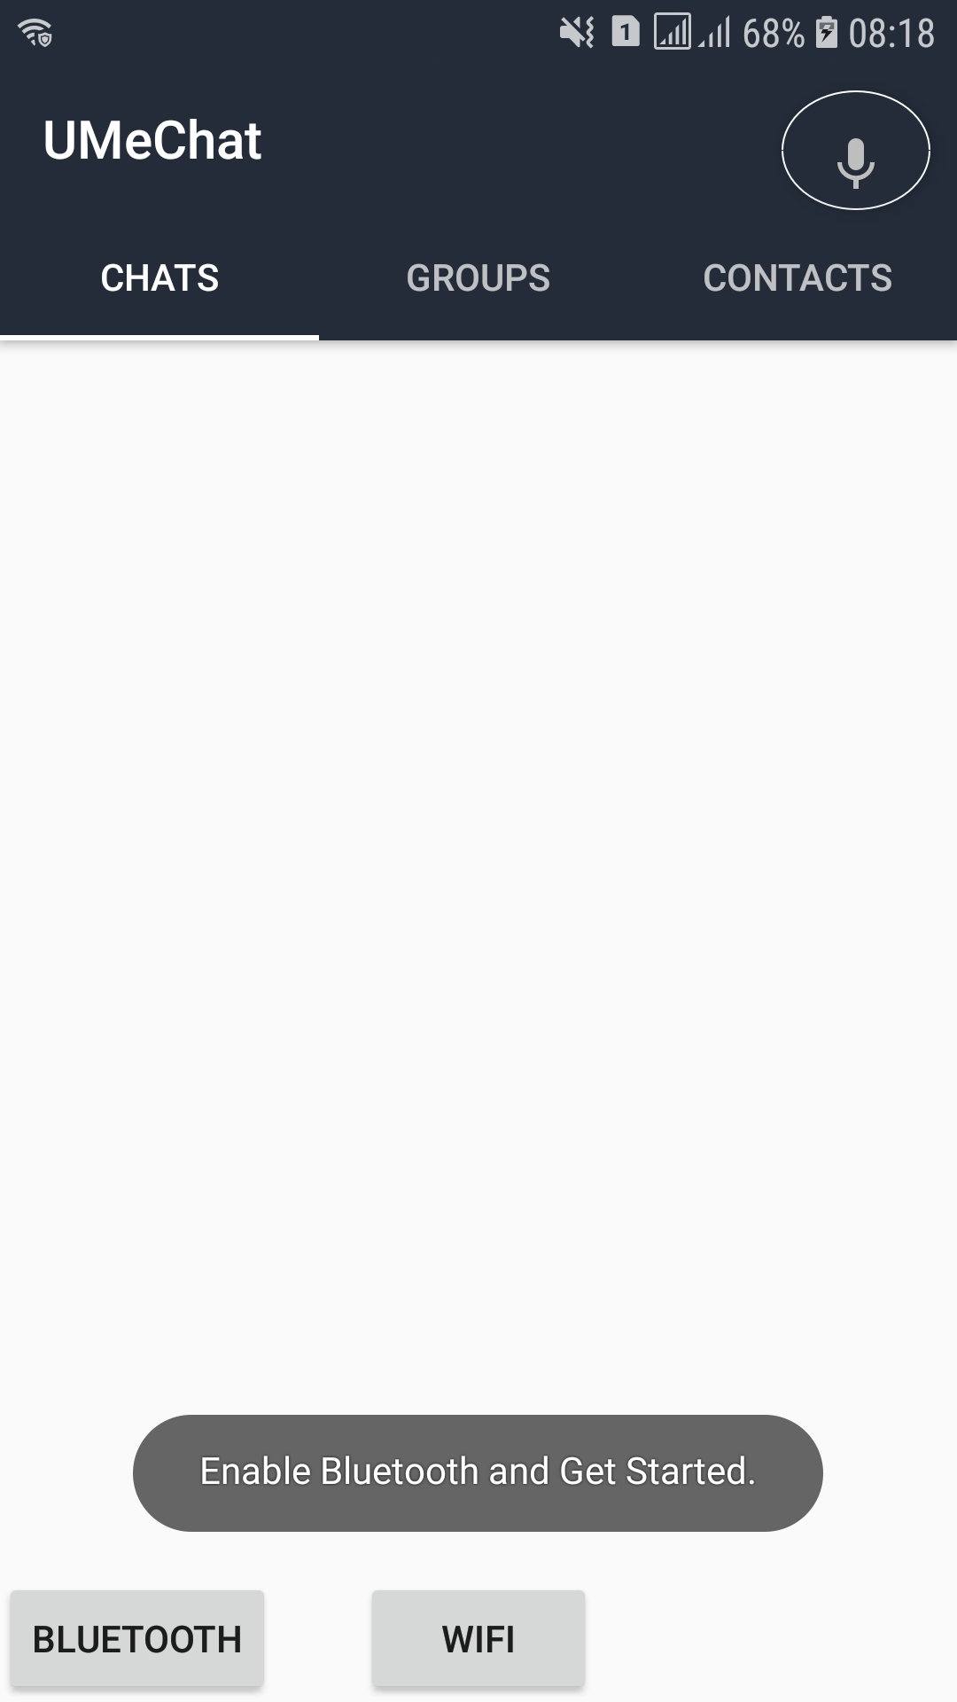

Permission for Bluetooth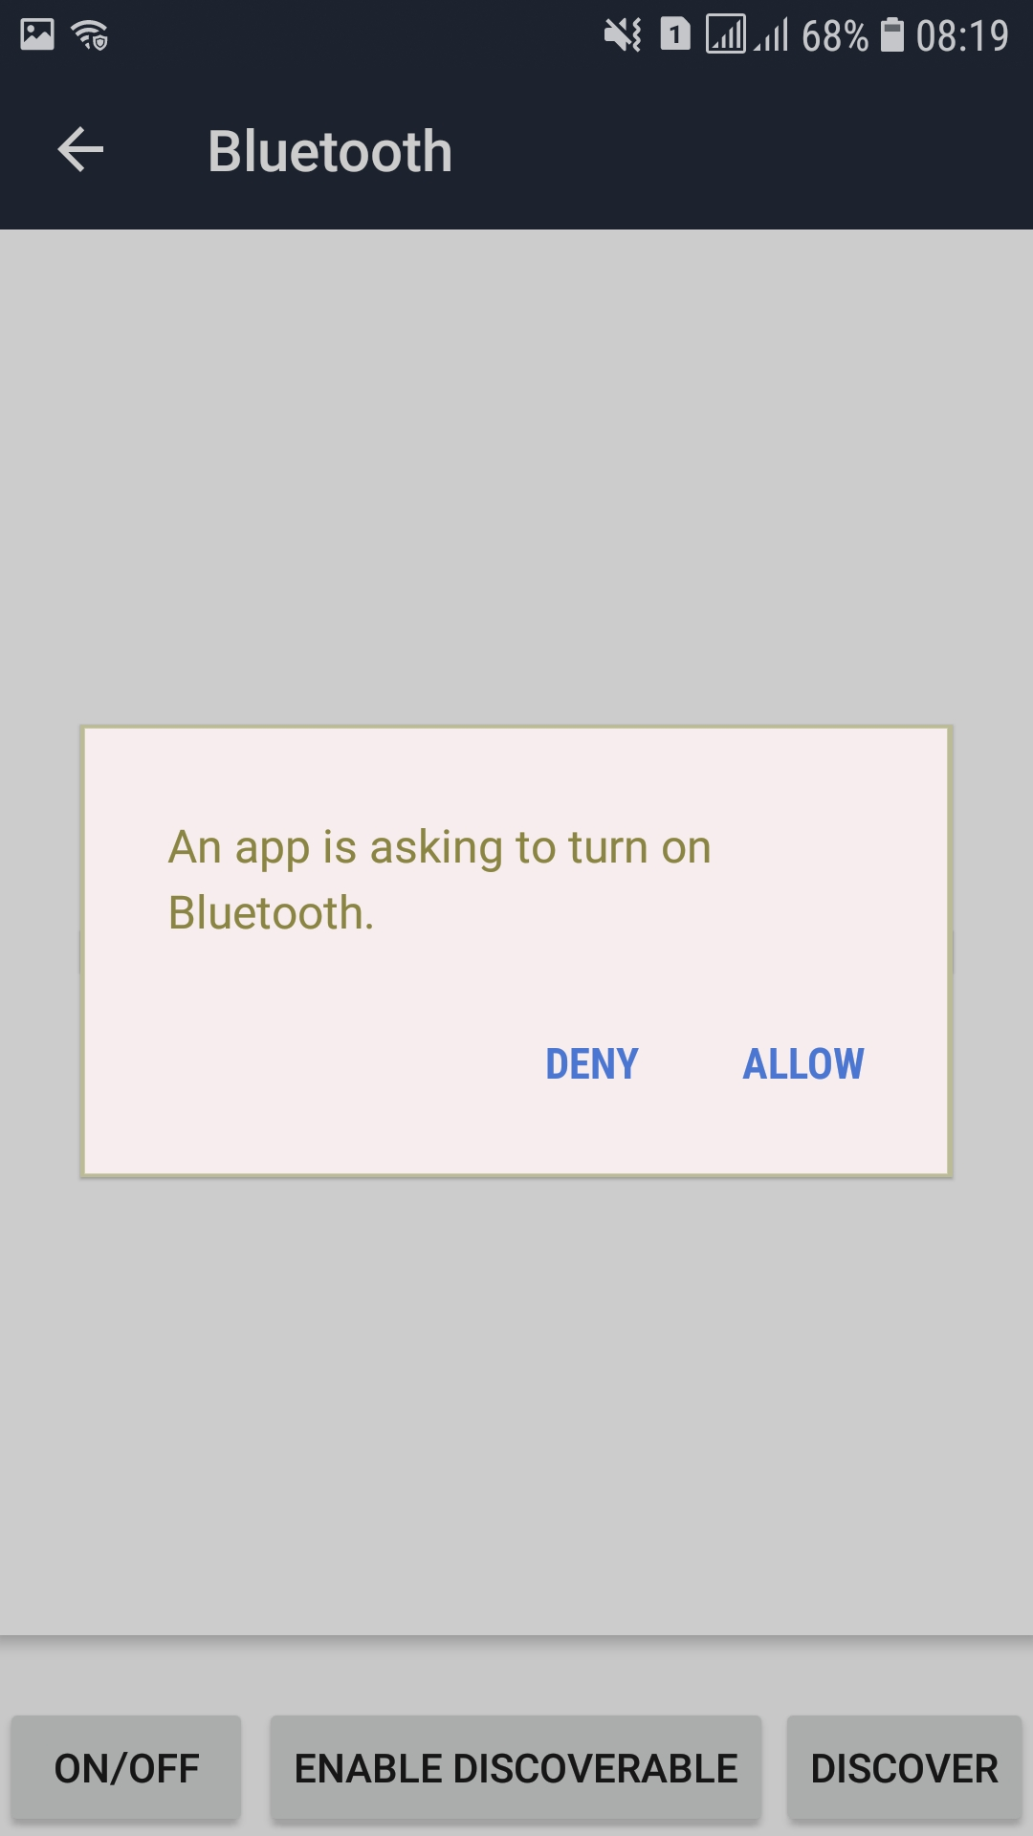

Permission for Bluetooth Discovery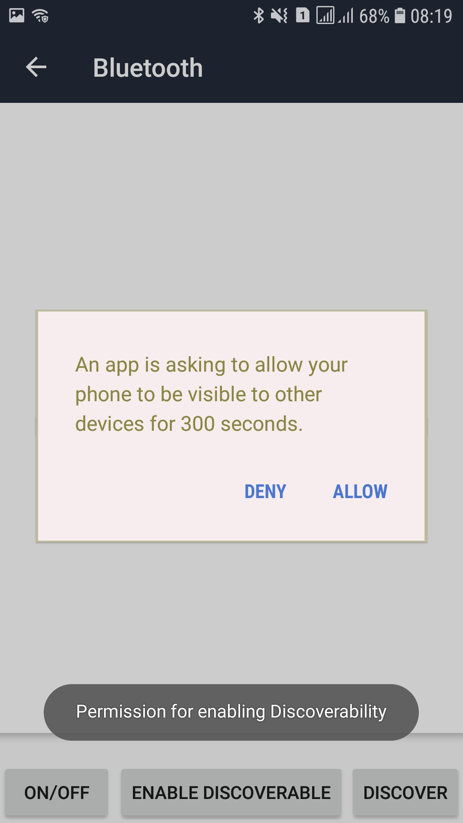

Permission for device location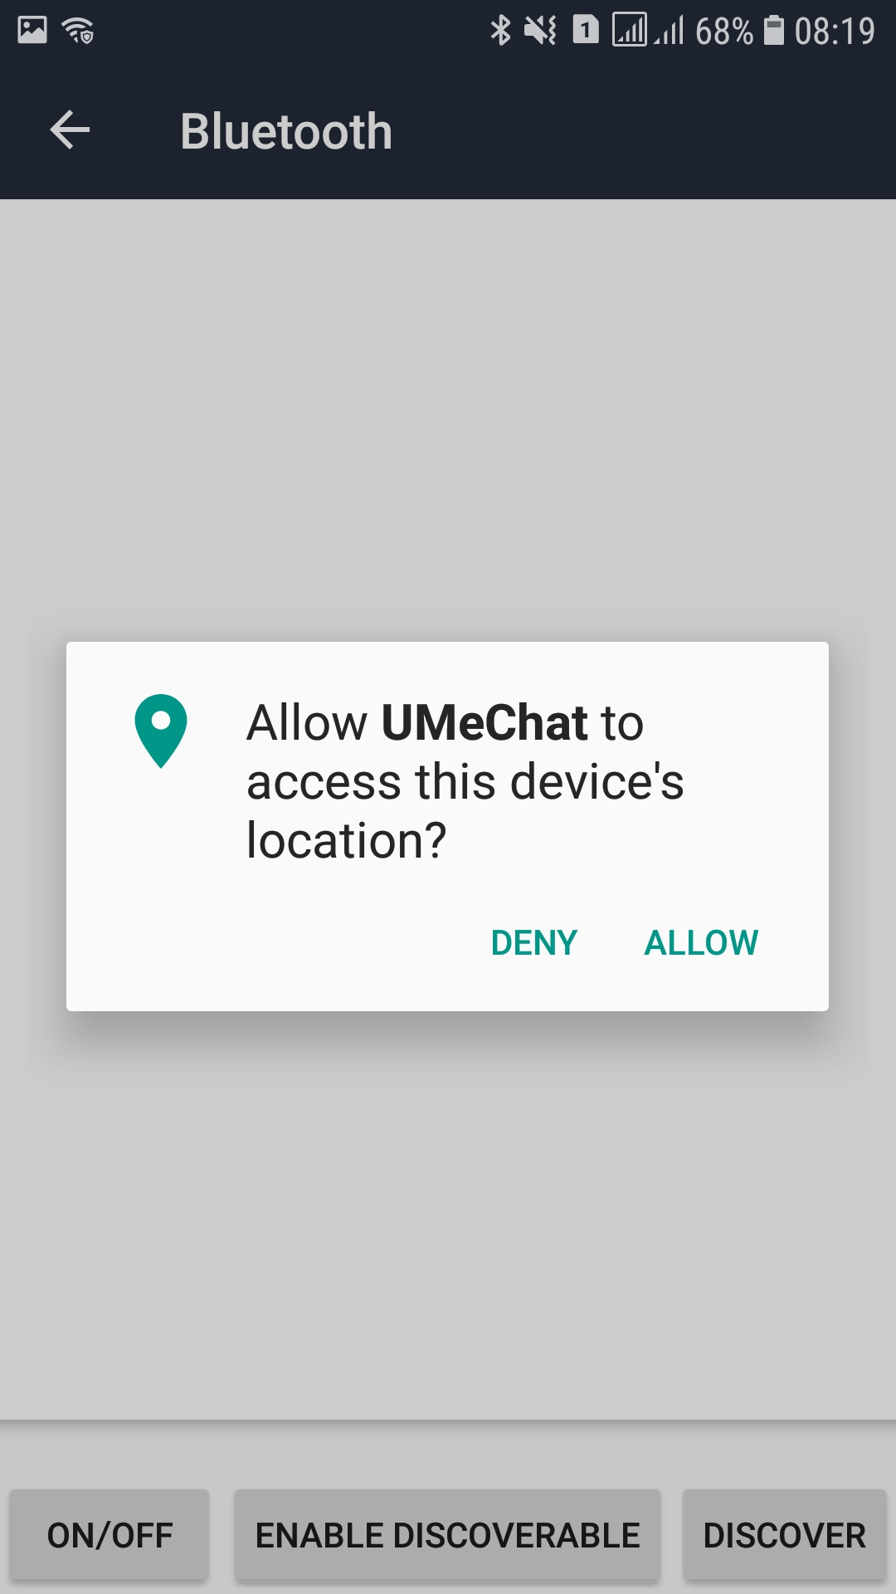

List of Available Devices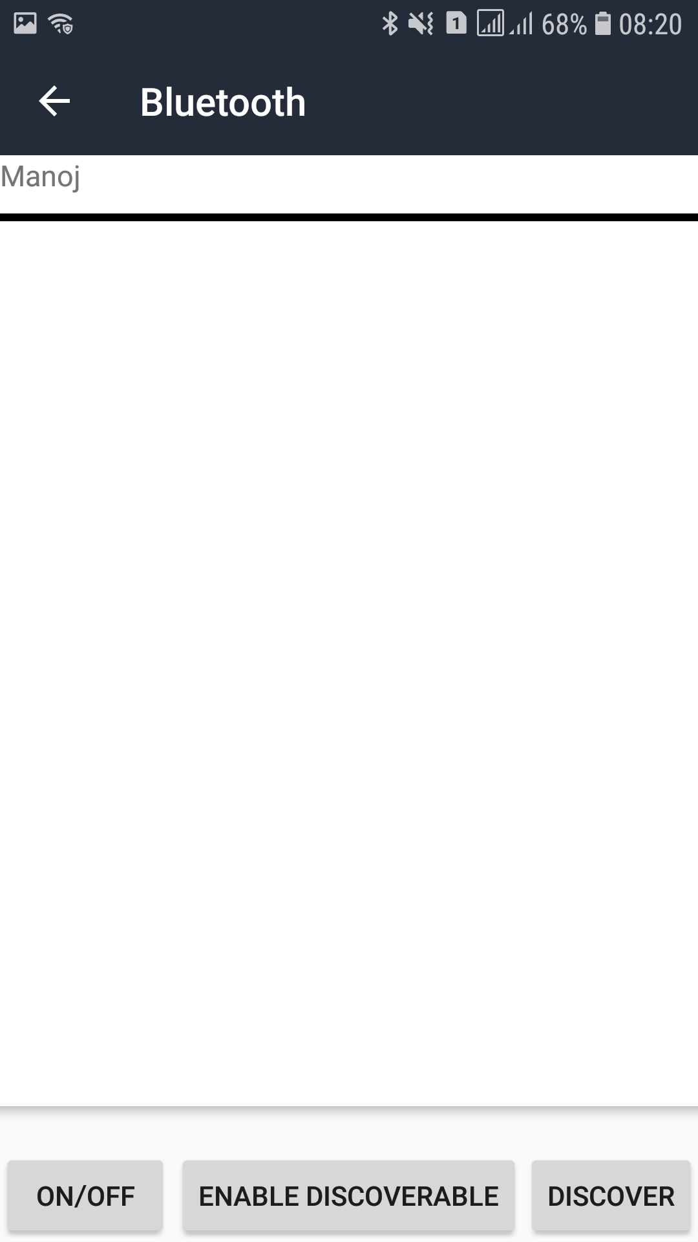

Pairing with Available Device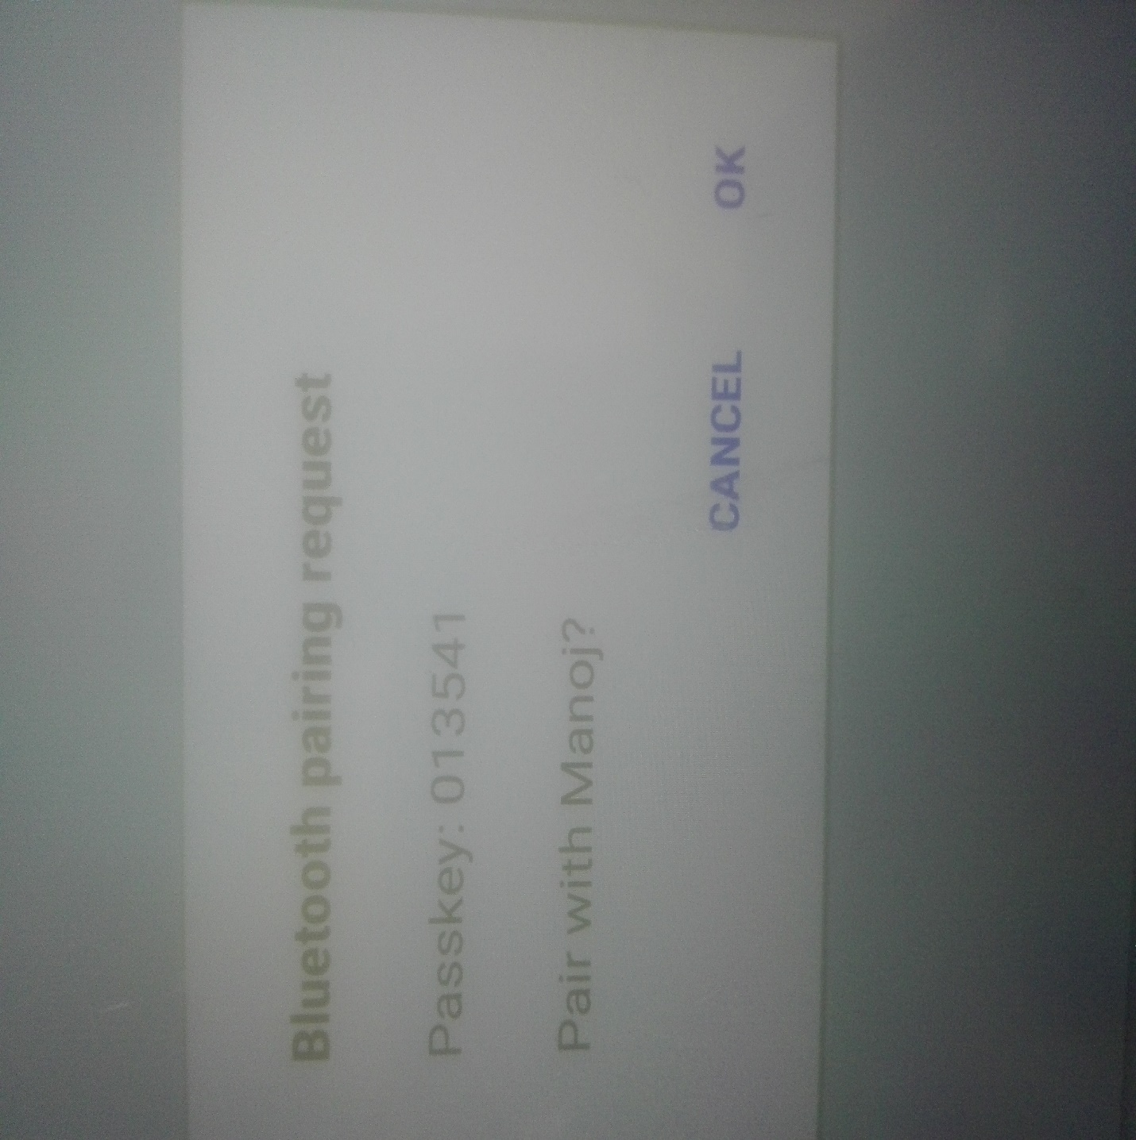

List of Paired Devices

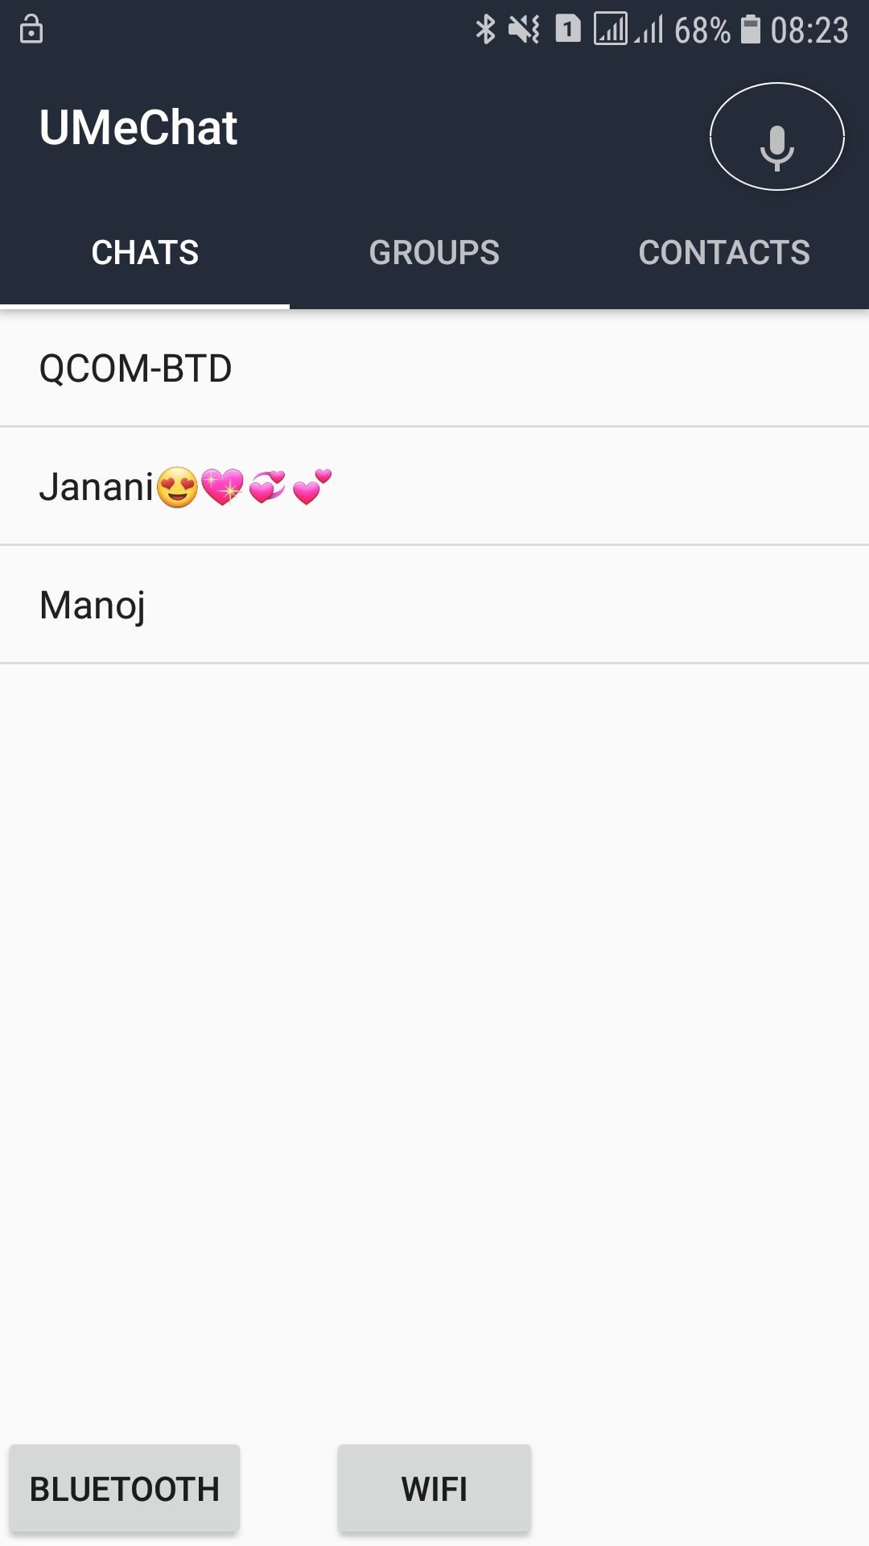

Refreshing List

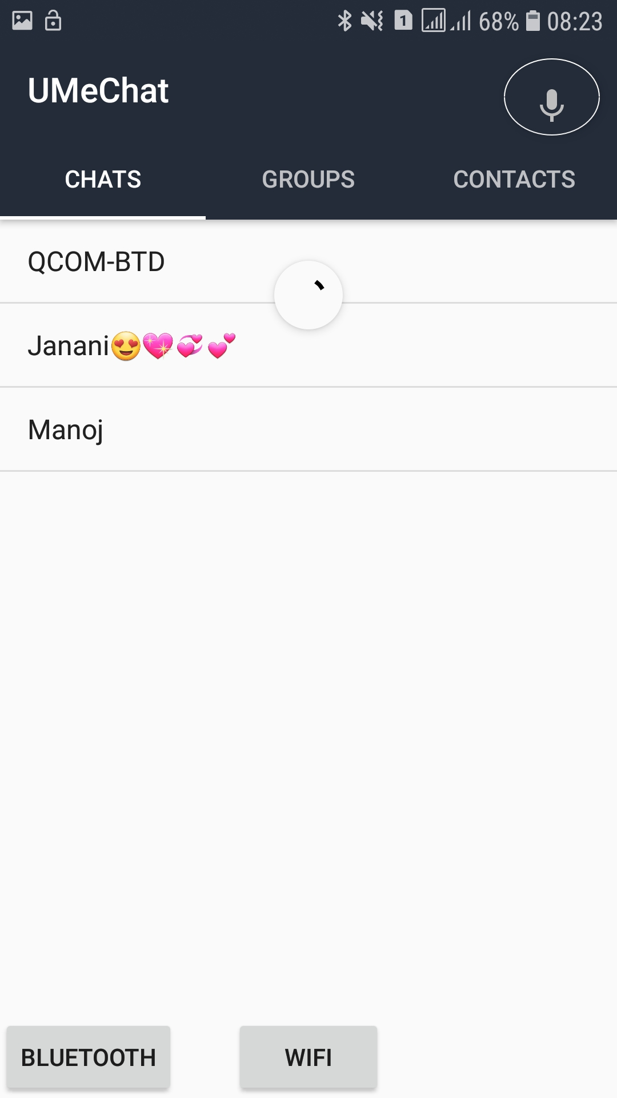

New Chat Activity

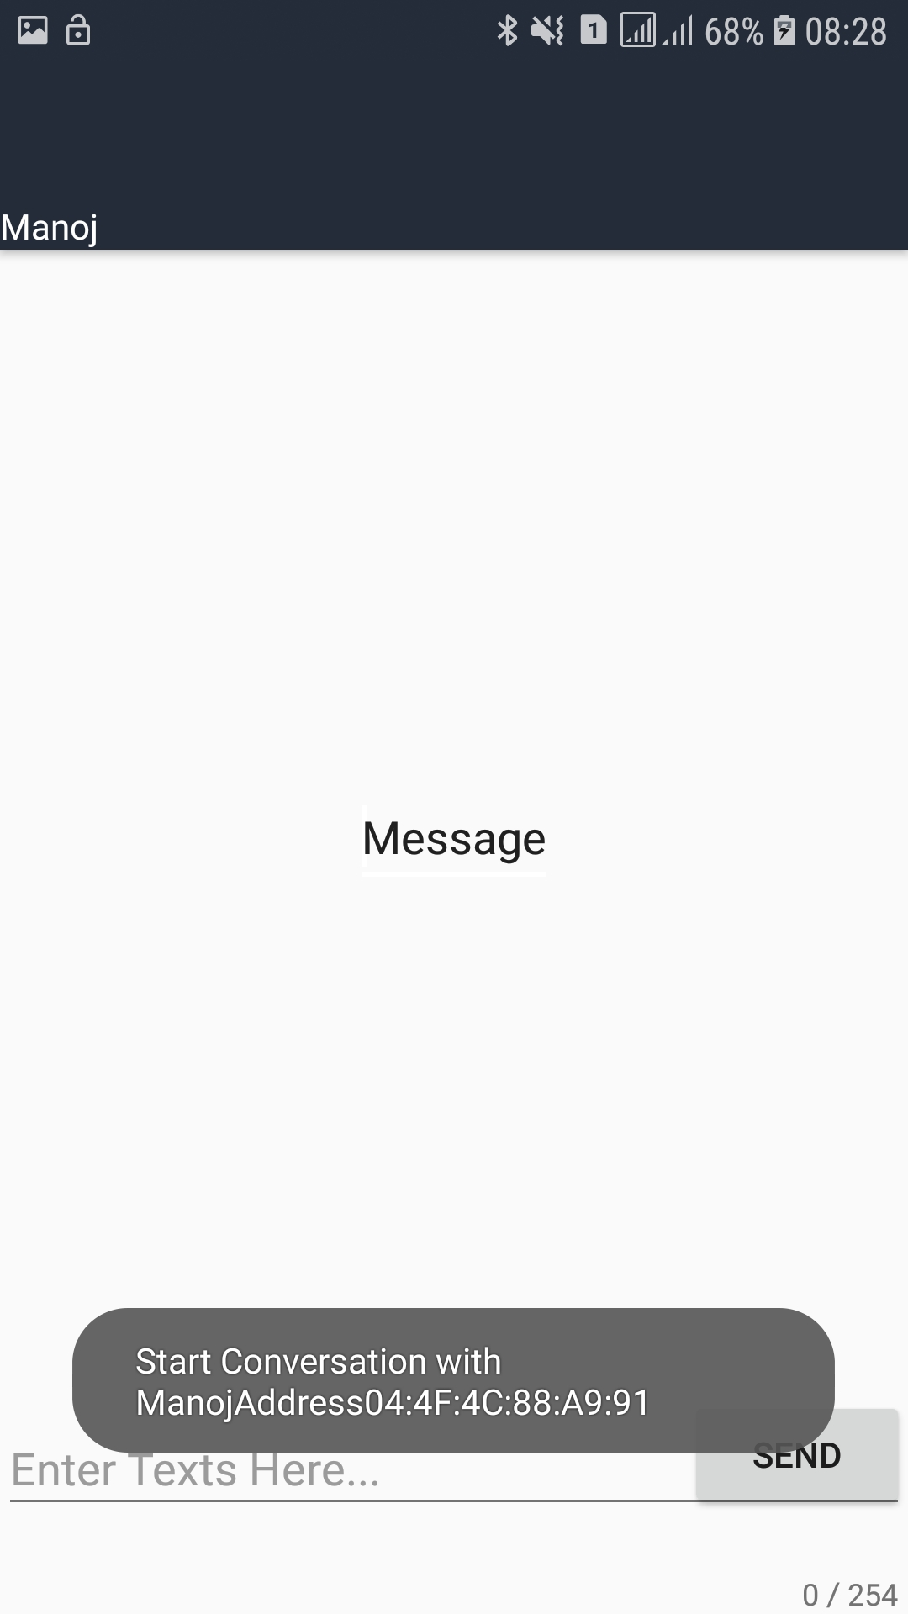

Location ON

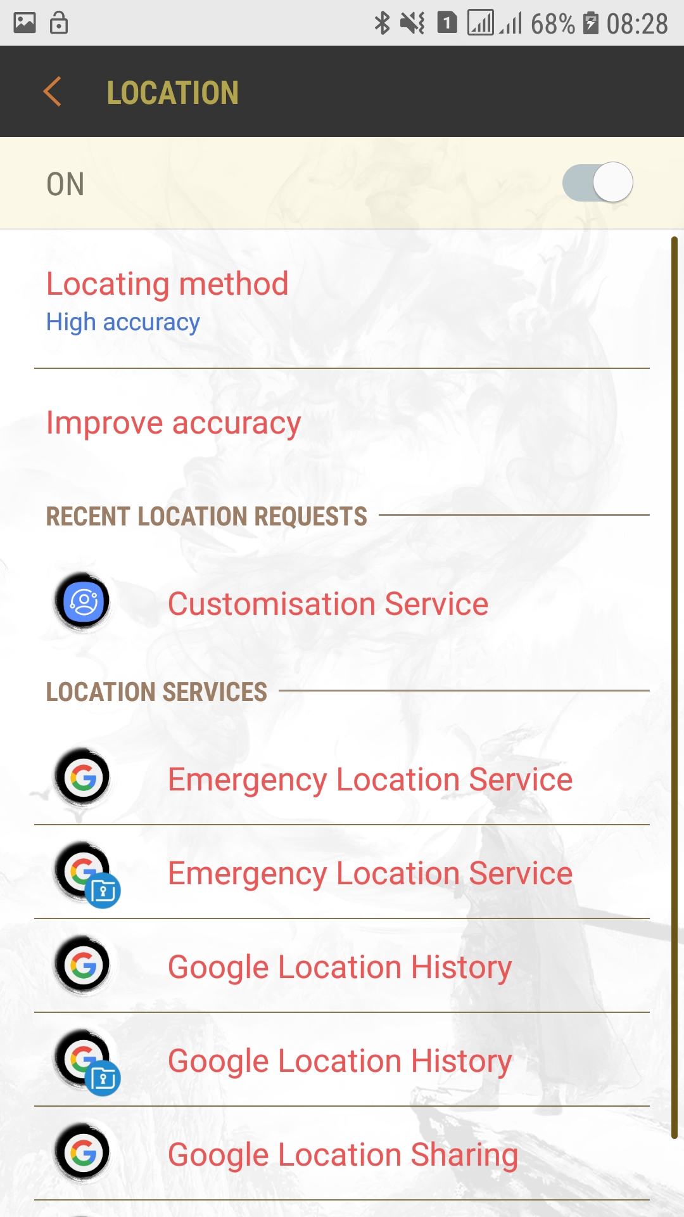

Wireless Chat Start Phase 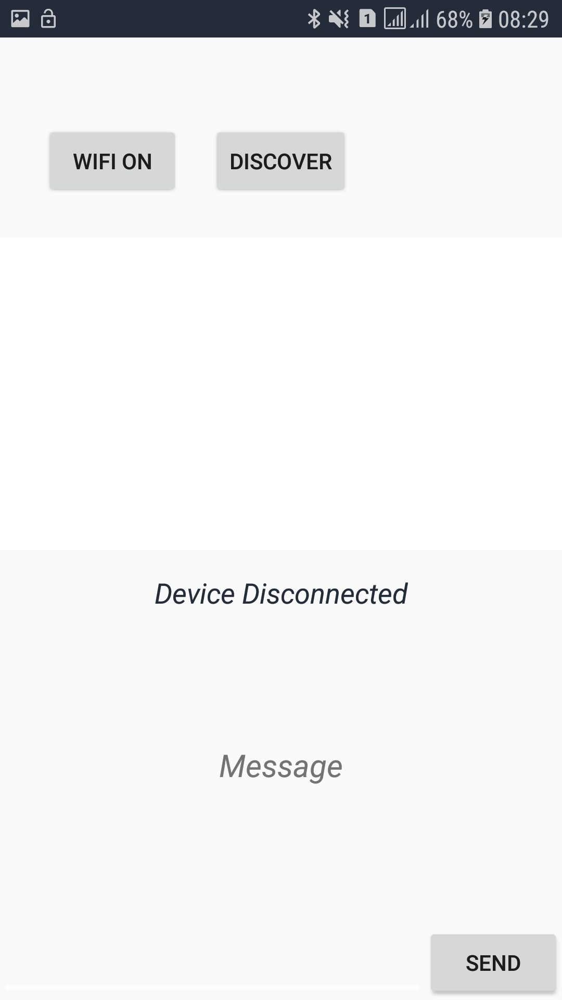

Enable WiFi

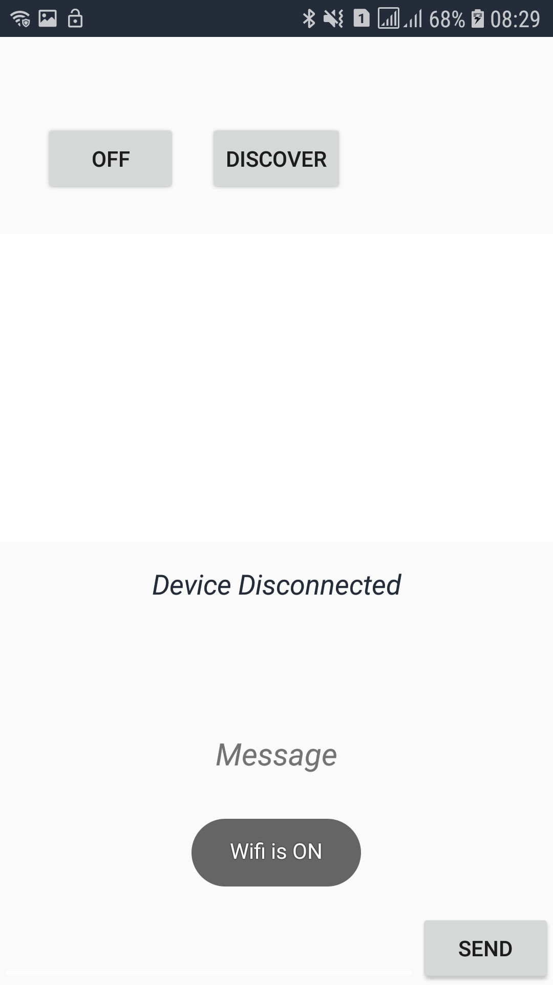

Enable WiFi

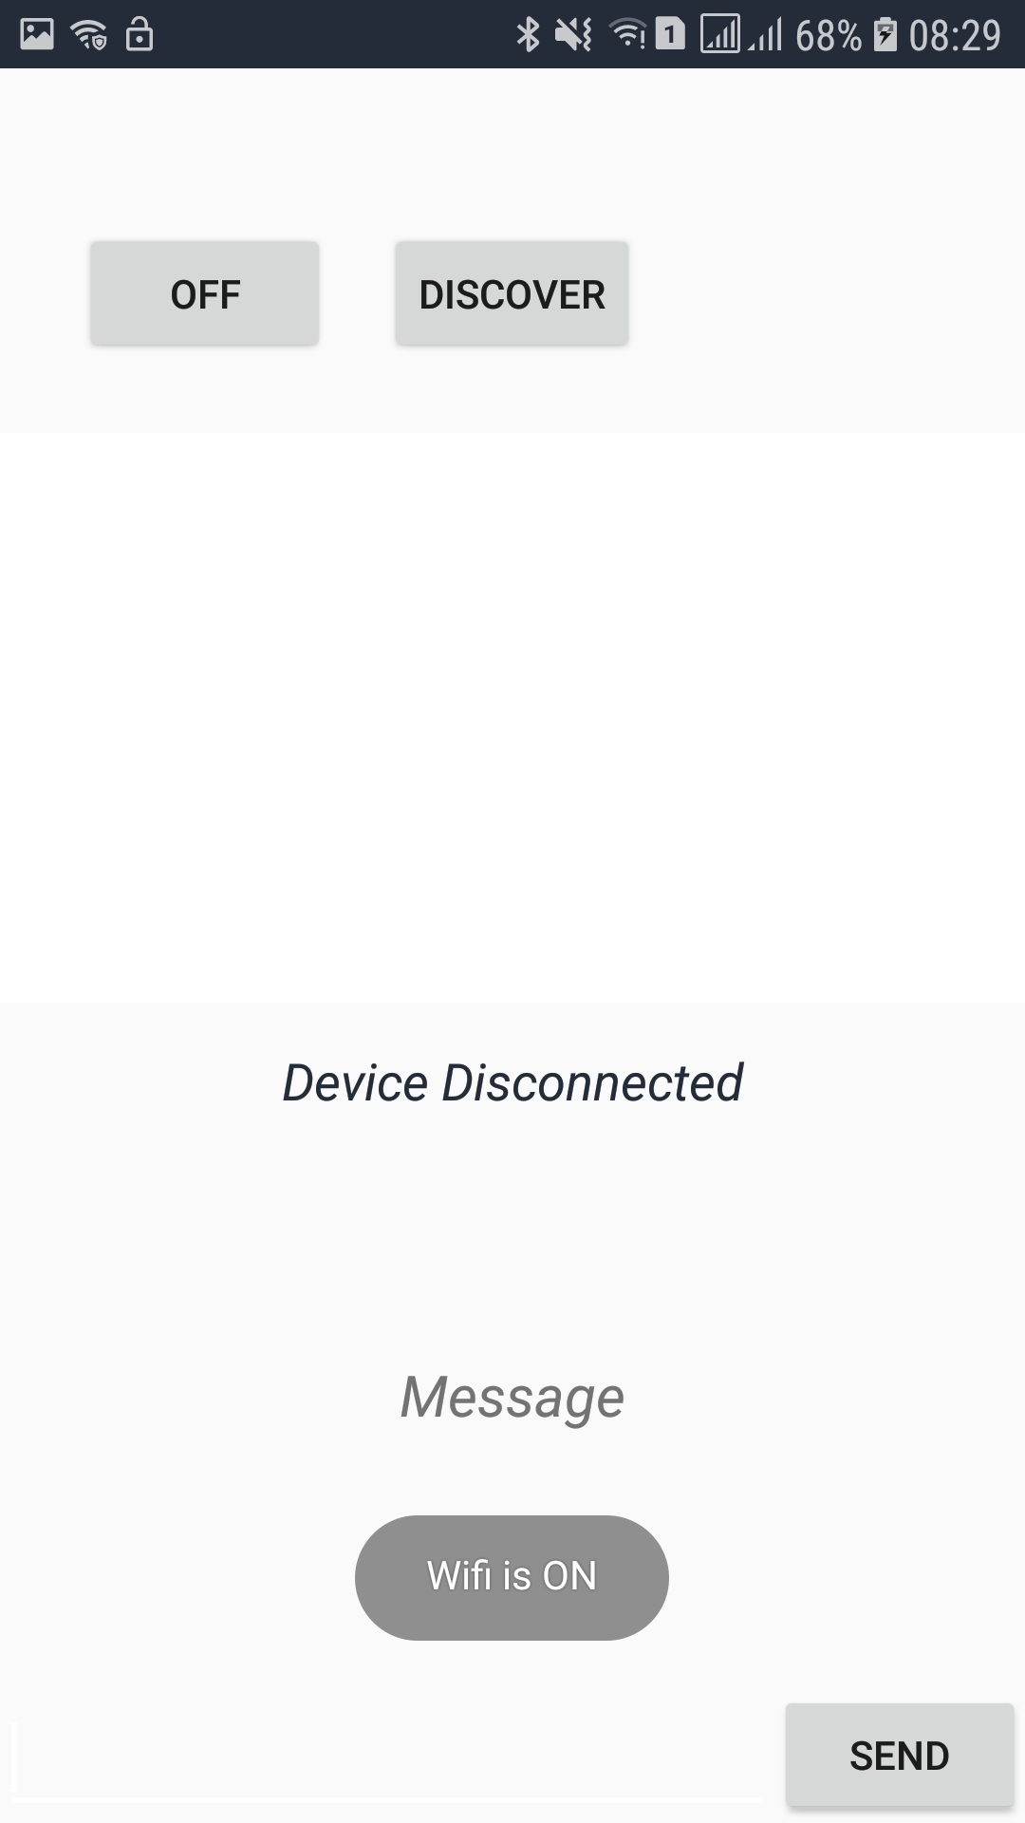

Discover Available Device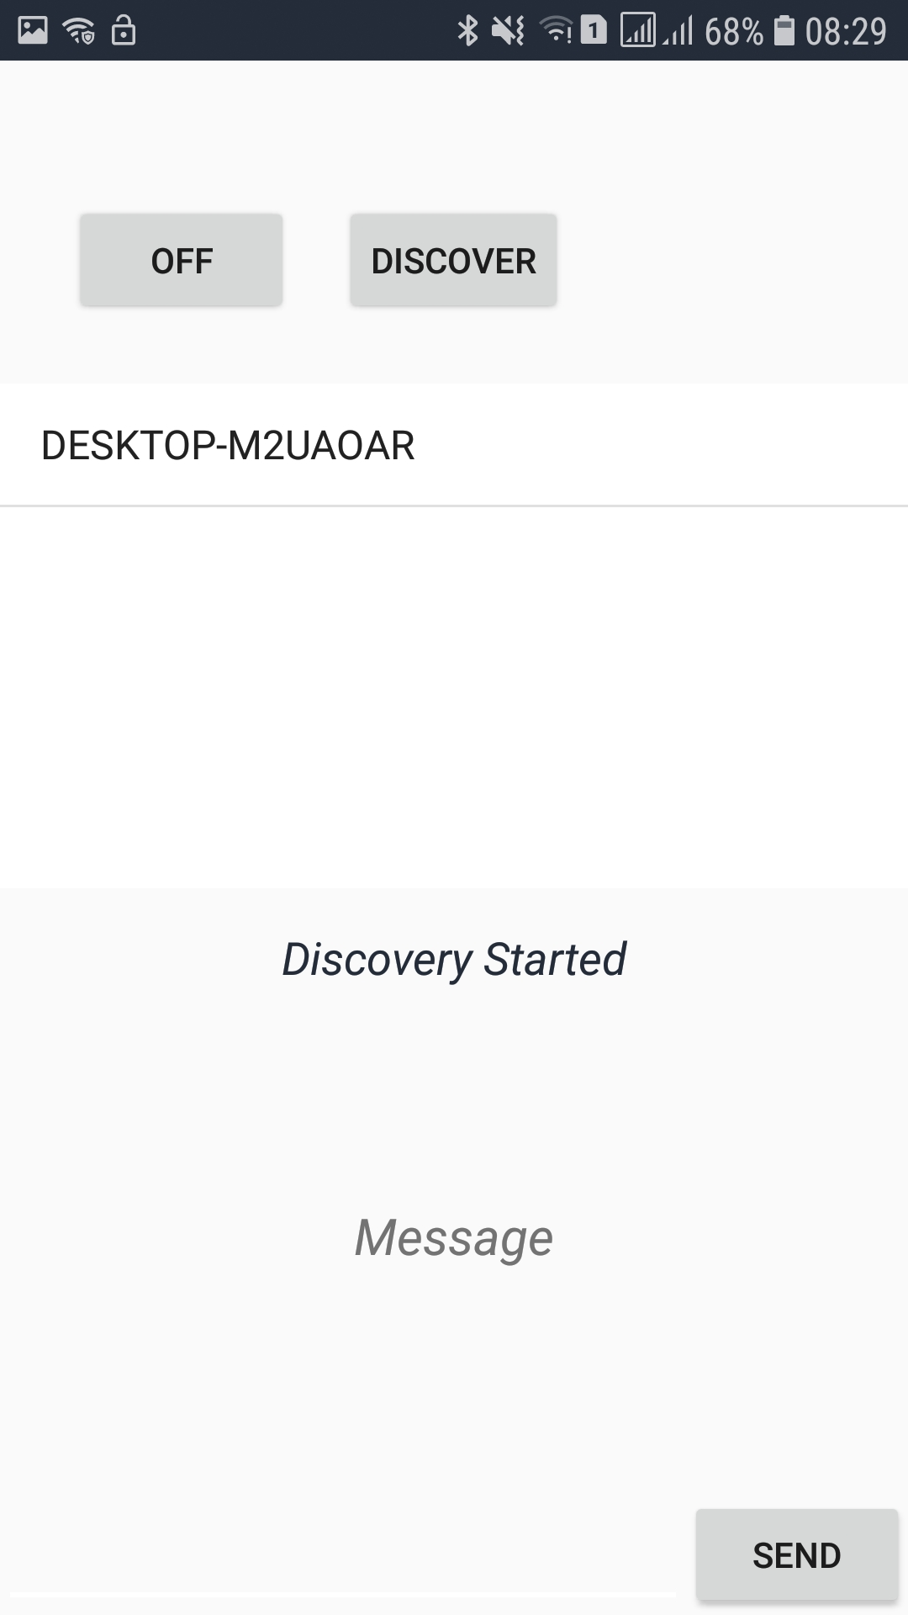

Connect Devices

